1.

Which of the following is the set of factors of 12?
A.
{12, 6, 4, 3, 2, 1}
B.
{12, 6, 4, 3, 2}
C.
{12, 6, 4, 2}
D.
{6, 4, 2, 1}
E.
{6, 4, 3, 2}

2.

Which of the following describes the relationship between the sets A and B in the Venn diagram below?
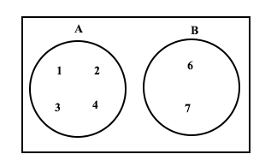
A.
A ⊂ B
B.
A ∩ B = 5
C.
A ∩ B = ∅
D.
A ∪ B = {1, 2, 3, 4, 5, 6, 7}
E.
B ⊂ A

3.

Mark is 30 years old. Yaw is half as old as Mark. Paul is 10 years older than Yaw. How old is Paul?
A.
30 years
B.
25 years
C.
20 years
D.
15 years
E.
10 years

4.

How many lines of symmetry does a rectangle have?
A.
1
B.
2
C.
3
D.
9
E.
11

5.

Which of the following is not a prime number?
A.
3
B.
5
C.
7
D.
9
E.
11

6.

If x = {1, 2, 3, 4, 5}, find the truth set of 2x + 1 < 7
A.
{1, 2}
B.
{2, 3}
C.
{1, 2, 3}
D.
{3}
E.
{2}

7.

In how many years will ₵5,000.00 yield a simple interest of ₵1,000.00 at a rate of 5% per annum.
A.
4 years
B.
5 years
C.
10 years
D.
25 years
E.
30 years

8.

Make m the subject of the relation f =
t
s
- m
A.
m =
t
s
+ f
B.
m =
t
s
- f
C.
m =
fs - t
s
D.
m = f -
t
s
E.
m = -f -
t
s

9.

Which property of arithmetic operation is illustrated by the statement: a × (b + c) = ab + ac?
A.
Addition
B.
Association
C.
Commutative
D.
Multiplication
E.
Distributive

10.

Simplify 15⁹ ÷ 15⁷
A.
30
B.
63
C.
225
D.
240
E.
625

11.

If
1
x
= 1
1
2
, find x.
A.
3
1
2
B.
3
2
C.
4
3
D.
2
3
E.
1
3

12.

Calculate the size of an exterior angle of a regular pentagon.
A.
72°
B.
90°
C.
108°
D.
360°
E.
540°

13.

Factorize x² – 5x + 6
A.
(x + 3)(x – 2)
B.
(x – 2)(x – 3)
C.
(x + 1)(x –6)
D.
(x + 2)(x + 3)
E.
(x + 6)(x – 1)

14.

Kwame, Atsu and Kojo shared a profit of ₵500,000.00 in the ratio 1 : 4 : 3 respectively. How much did Atsu get?
A.
₵62,500.00
B.
₵125,000.00
C.
₵187,500.00
D.
₵250,000.00
E.
₵312,500.00

15.

Use the identity a² – b² = (a + b)(a – b) to evaluate 83² - 17²
A.
660
B.
6,600
C.
7,178
D.
7,600
E.
8,317

16.

What is the probability of obtaining a prime number when a fair die is thrown once?
A.
2
3
B.
1
2
C.
1
3
D.
1
6
E.
5
6

17.

The following are the scores obtained by girls in a beauty contest: 12, 16, 19, 14, 17, 8, 11, 19.
What is the probability of obtaining a score of 19?
A.
1
9
B.
1
8
C.
1
4
D.
19
53
E.
19
108

18.

Express 25 as a percentage of 75.
A.
300%
B.
100%
C.
50%
D.
33.3%
E.
25%

19.

Find the value of m given that m = (3⁶ ÷ 3⁴) × 27
A.
3¹
B.
3²
C.
3⁵
D.
3⁶
E.
3¹³

20.

Express 0.0043216 in standard form.
A.
4.3216 x 10⁻⁴
B.
4.3216 x 10⁻³
C.
4.3216 x 10
D.
4.3216 x 10³
E.
4.3216 x 10⁴

21.

Given that a = 2 and b = 3, evaluate (2a + b) (a – 2b)
A.
28
B.
8
C.
–7
D.
–8
E.
–28

22.

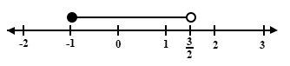
Which of the following is illustrated on the number line above?
A.
–1 < x <
3
2
B.
–1 ≤ x <
3
2
C.
–1 ≤ x ≤
3
2
D.
–1 < x ≤
3
2
E.
3
2
≤ x ≤ –1

23.

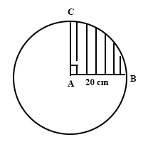
In the diagram above, A is the centre of the circle with radius 20 cm. If angle BAC is 90°, find the perimeter of the shaded sector.
[Take π =
22
7
]
A.
31.4 cm
B.
31.8 cm
C.
40.0 cm
D.
51.4 cm
E.
71.4 cm

24.

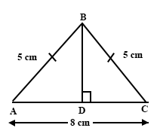
In triangle ABC, |AB| = |BC| = 5 cm, and |AC| = 8 cm.
Find |BD|.
A.
3 cm
B.
4 cm
C.
9 cm
D.
33 cm
E.
41 cm

25.

Write ₵35,632.00 correct to the nearest thousand cedis.
A.
₵40,000.00
B.
₵36,000.00
C.
₵35,600.00
D.
₵35,000.00
E.
₵30,000.00

26.

Solve for x if 2x + 5 = 3x – 7
A.
12
B.
2
C.
2
3
D.
–2
E.
–12

27.

Evaluate
(
2
3
−
1
4
)÷
5
6
.
A.
1
2
B.
1
5
C.
2
3
D.
-2
E.
-12

28.

A boy walked 7 km on a bearing 060°. Which of the following diagrams shows his direction.
A.
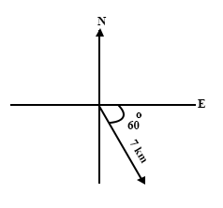
B.
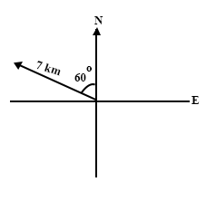
C.
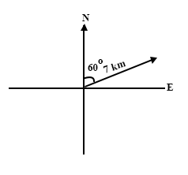
D.
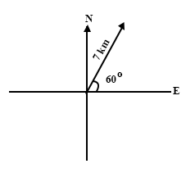
E.
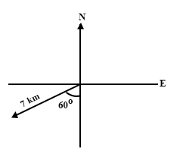

29.

In the diagram, G₁OH₁ is an enlargement of triangle GOH with scale factor k. If |GG₁| = 5cm, |GO| = 2 cm and |G₁H₁| = 1 cm, what is the value of k?
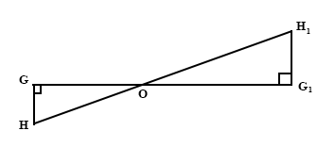
A.
-
5
2
B.
-
3
2
C.
-
2
5
D.
2
3
E.
3
2

30.

If 14_{x} = 9_{ten}, find x.
A.
Nine
B.
Eight
C.
Seven
D.
Six
E.
Five

31.

How many faces has a cuboid?
A.
6
B.
8
C.
12
D.
16
E.
32

32.

Which of the following is a factor of the expression ac – 2bc + ad – 2bd?
A.
c – d
B.
a – 2b
C.
a + b
D.
a + 2b
E.
c + 2d

33.

Three boys weeded a piece of land in 4 hours. How long would it take 18 boys to weed the same piece of land weeding at the same rate?
A.
2
3
hour
B.
3
1
3
hours
C.
4
2
3
D.
22 hours
E.
24 hours

34.

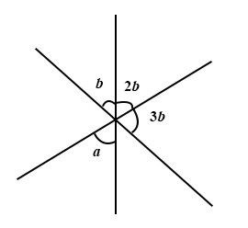
Find the size of the angle marked a in the diagram above.
A.
30°
B.
60°
C.
90°
D.
120°
E.
180°

35.

Which of the following is the net of a cube?
A.
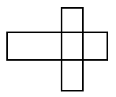
B.
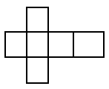
C.
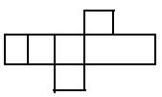
D.
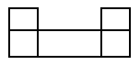
E.
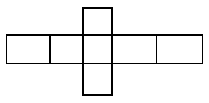

36.

Use the mapping below to answer the question below
5 → 10_{five}
10 → 20_{five}
20 → 40_{five}
40 → x_{five}
y → 310_{five}
Find the value of x
A.
30_{five}
B.
100_{five}
C.
110_{five}
D.
120_{five}
E.
130_{five}

37.

In the diagram below, find the size of the angle marked e°.
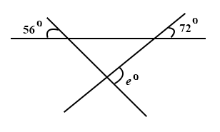
A.
52°
B.
56°
C.
72°
D.
108°
E.
128°

38.

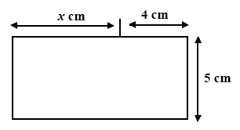
If the area of the figure above is 60 cm², find x.
A.
8 cm
B.
9 cm
C.
12 cm
D.
16 cm
E.
20 cm

39.

The mean of the numbers 4, 3, 3, x is 5, find x
A.
20
B.
10
C.
5
D.
4
E.
3

40.

If a number is selected at random from the table below, what is the probability that the number is 5?
Number | 1 | 3 | 5 | 7 | 9
Frequency | 25 | 15 | 8 | 10 | 2
A.
8
25
B.
4
25
C.
1
12
D.
2
15
E.
5
8

